Author: Alison Syme
Date: Winter 2020
From: Victorian Studies(Vol. 62, Issue 2)
Publisher: Indiana University Press
The Media of Sight: Burne-Jones and the Graiae
Over the course of the evolution of his never-completed Perseus series, Edward Burne-Jones made three different full-size versions of the scene of Perseus stealing the shared eye of the Graiae. Closely examining the changes from the initial multimedia relief panel incorporating text and image through the final, wordless oil, I argue that all three of the Graiae works engage with and invoke diverse historical and contemporary art forms even as they invite reflection upon the media--as much as the medium--of sight. As a story that revolves around shared vision and blindness, Perseus and the Graiae, in Burne-Jones's renderings, provokes consideration of the communal forms shaping the Victorian media landscape and field of vision. Highlighting those forms related to book and print culture, I explore what possibilities medial intersections, allusions, and translations held for the artist at various points in his career.
Over the course of the evolution of his Perseus series, Edward Burne-Jones made three different full-size versions of the scene of Perseus and the Graiae, the three "grey sisters" who share one eye. Each depicts Perseus, having arrived at the home of the Graiae, stealing their organ of sight so he can extract knowledge from them. While retaining a nearly identical figural arrangement, the versions chart the development of the artist's conception from an overtly multimedia relief panel incorporating text and image to a final, wordless oil. Despite the move to an ostensibly singular medium, however, all of the Graiae works invoke diverse historical and contemporary artforms, and invite reflection upon the media, as much as the medium, of sight. I argue that in Burne-Jones's renderings, the story of Perseus and the Graiae--one that revolves around shared vision and blindness--provokes consideration of the communal forms and signifying systems shaping the Victorian media landscape and field of vision. I highlight those related to book and print culture here, rather than focusing on the numerous art historical references in the works. My goal is to situate Burne-Jones's works in a "matrix of interrelated media," to borrow a phrase from Carol Armstrong (7); to identify instances of medial intersection, allusion, and translation; and to begin to consider what these meant at different points in the artist's career.
Burne-Jones began designing the Perseus series in 1875. Intended to decorate a room in Arthur Balfour's Neoclassical home in London, the series, as originally conceived, was to have consisted of six paintings and four mixed media works on oak panels. An acanthus pattern by William Morris, wrought in gesso on an oak base and covered with silver and gold leaf, would have surrounded them. This initial scheme went through numerous changes over the decade and a half that Burne-Jones worked on it. All the multimedia panels were jettisoned, and some of the initial ideas for pictures were reworked. Although the artist produced ten full-size gouache cartoons for different scenes, which are now in the Southampton City Art Gallery, a completed version of the series was never achieved. The Staatsgalerie Stuttgart holds the four finished oils, along with two unfinished ones and two full-sized cartoons.
Burne-Jones's first attempt to depict the Perseus legend was as an accompaniment to "The Doom of King Acrisius" in Morris's Earthly Paradise. In the 1860s, Burne-Jones planned twenty-eight woodcuts for the tale, as Morris had wanted to have the book printed with hundreds of illustrations. (1) This overambitious project was also never completed, but I would suggest that the bookish origins of the Perseus series--and specifically its planned printing--informed its subsequent iterations. (2) This is particularly evident in the only multimedia panel Burne-Jones completed, Perseus and the Graiae (fig. 1). Dated 1877-78 and now in Cardiff, it is one of the two works in the series that combine text and image. (3) A Latin summary of the scenes in Burne-Jones's cycle provided by the Oxford Classicist Richard Jebb runs above the figures. (4) The golden letters, like the coppery robes of the Graiae and the silver armor of Perseus, are relief elements, and recall not only monumental Roman inscriptions but also the gold majuscule script in the unfinished Aeneid manuscript that Morris, Burne-Jones, and assistants were working on in 1874-75. In contrast to the raised letters and robes, the heads and appendages of the figures are rendered in oil paint on the oak board, and a few contours of a rocky landscape are faintly sketched in beneath the figures.
When Burne-Jones exhibited this panel at the Grosvenor Gallery in 1878, the response was largely, though not entirely, negative. Commentators did not say much about the combination of text and image, but they were unanimous in calling attention both to the panel's strangeness and to its unexpected evocations. While the relief elements are made of gilded, bronzed, or silvered gesso, almost all the reviewers saw them as solid or gilded metal and dwelt upon the work's material associations with other artistic and visual cultural traditions. One critic described the panel as being no different artistically from "the tiaras fitted with real precious stones in the mediaeval pictures of Madonnas and saints" ("Picture Galleries" 692), perhaps thinking of a Crivelli acquired by the National Gallery in 1868. (5) Another found the "combination of the positive metal with the conventional and interpretive method of linear art or colour" akin to "early Japanese art" ("Grosvenor," Magazine of Art 111). And the reviewer for Punch pointed out the resemblance to tinsel prints (fig. 2), which depicted characters for toy theaters--often real actors in roles they were known for, especially valiant knights--that could be coloured and ornamented with "bright little round buttons of tinsel" ("Our Guide" 285).
The discrepancy between the raised "metal" garments and flesh painted on the panel was regarded as particularly problematic. Although one sympathetic reviewer suggested replacing the painted heads with plates "of ivory, mother of pearl, or some more precious material than the wood background," the rest found the juxtaposition of two-dimensional representation and three-dimensional relief childish and primitive ("Grosvenor," British Architect 239). One considered the mixture of oil and relief a "barbarism" suitable for earlier times but not "when deliberately assumed by modern knowledge"; its effect was to "destroy history, and the charm and meaning of its ages of development" ("Grosvenor," Magazine of Art 111). The perceived destruction of a progressive timeline of the history of art through the mixed-media work's suggestions of medieval saints and Japanese art (suggestions that only accentuate what is already stylistically obvious in the combination of Perseus's medievalizing armor, Roman type, and ancient Greek drapery and story) throws into relief the media-purifying expectations at least some Victorian critics of the late 1870s brought to the scene.
To continue with its provocations, the panel's temporal confusions are echoed by its spatial ones. The faintly sketched-in rocky landscape can be either imaginarily invested with weight and solidity by the viewer or the figures can be seen as floating attachments to the wood panel. More immediately noticeable, the dazzling optical effects of the gilded gesso, which is almost mesmerizing in its relentless undulations, draw our attention away from the scene of narratable action (or at least narrative suspense) and toward an appreciation of surface ornament. Caroline Arscott has astutely described the challenge these effects present to the kind of "intellectual control associated with vision organised by the perspectival scheme proper to neoclassical history painting," a point to which I will return below (63). For the moment, though, I want to consider the effects of the gesso in the light of medial interplay. One effect of the highly reflective surface is that, with a shift in position, what is light can become dark, most noticeably in Perseus's torso and leg armor but also in the drapery of the Graiae, which can oscillate between light and dark, positive and negative. Interest in such inversions would lead Burne-Jones to take up metallic drawings on colored paper in later life, but one of the most obvious prompts to his exploration of this capacity for reversal of light and dark was his interest in and experimentation with prints.
Indeed, the modelled, copper- and silver-colored raiments of the Graiae and Perseus evoke not only tinsel prints but also the grooves and material of copper and steel engraving plates, and perhaps even the relatively new technique of electrotyping. Burne-Jones seems also to be referencing, with his oak panel, the woodblocks on which he would have drawn the originally planned Perseus illustrations. Extant cut and uncut blocks with his drawings for another story in the Earthly Paradise reveal chromatic and stylistic affinities with the Graiae panel, though the linework is more fluid in the gesso robes (fig. 3). Notably, in the Tate's set of preliminary watercolors outlining the scheme, the rightmost Graia's left sleeve is marked with white lines, which read less as indications of detail than as instructions for incising on a wood ground. (6) While the Cardiff panel alludes to the earlier abandoned project, it also gestures toward a different way of combining text and image. The Earthly Paradise was never realized in its planned form not only because the scale of the project was too large, but also because the text and images did not harmonize. Trial pages show the darkly framed, deliberately rather crude wood engravings, done mostly by amateurs in Morris's circle, overpowering the text. (7) Burne-Jones's panel, with its lettering elegantly spaced above the figures, and the continuity of color, weight, and shared level of relief between the two, seems to represent a fantasy that text and image can be presented together harmoniously--in a manner that Morris and Burne-Jones would not realize in print until the founding of the Kelmscott Press in the 1890s.
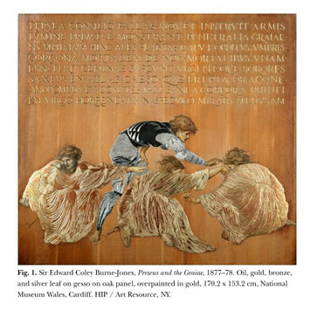
The panel's allusions to various types of printmaking and print cultural phenomena--and particularly an ideal of bookmaking--suggest that Burne-Jones saw his role as artist as that of an imaginary compositor as much as a sculptor, painter, decorator, and illuminator. He was not, however, simply mimicking other materials and drawing on the logic of other representational forms. Rather, I would argue that identifying points of medial intersection was important to his project. Let us take a closer look at the depicted scene. Perseus is shown reaching into the Graiae's sororal circuit so he can steal their eye and compel them to tell him the location of the Stygian nymphs who can give him the winged sandals he needs to reach Medusa. Having snatched their eye, he is not seen by the Graiae, and his invisibility to them is suggested by the ghostly silvering of his armor in contrast to their gold and coppery robes. What catches my eye in this scene of literal eye-catching is the link between text and image the Graiae's eye provides (fig. 4). In the epigraph, the words are separated by dots or interpuncts. If the tinsel-button-like eye of the Graiae radiates little lines of gold, it is nevertheless visually and materially equivalent to one of those interpuncts. The identity of golden eye and typographical element plays into the thematics of the panel, which almost literally textualizes the eye and vision to show how representational forms and systems shape sight. Sight and selfhood are also connected through the eye, for although there are no miniscule letters in the majuscule inscription above, the eye suggests the dot of a miniscule "i" (the diacritic known as a "tittle"), invoking the homophony between the letter, the organ, and the pronoun. In Morris's poem, the eye invites play with such linguistic shifters: when Perseus grasps it, one of the Graiae exclaims, "verily he has the eye of me" (254). Here, in its slippage between pictorial and typographic registers, the itinerant eye functions similarly as a shifter between different media, modes of seeing, and points of view.
Further light can be shed on Burne-Jones's tittle-ating conflation of organ and sign by continuing our consideration of the evolution of the Graiae scene in Burne-Jones's decorative scheme. After receiving such negative reviews in 1878, the artist abandoned all four of the originally planned relief panels, but not the text-image scheme. A full-size gouache cartoon of the scene produced between 1877 and 1880 retains the Latin summary, which now appears in a paler gold against a gold-framed blue ground (fig. 5). (8) The undulant rocky backdrop is fully filled in, its curves heightening the sense of the swirling circularity of the sisters' organic connection, even though they are depicted in a frieze-like row. And the gray sisters appear in gray robes, although, contrary to some versions of the myth, they are still portrayed as youthful. Perseus has captured the eye, which is depicted with a pale blue iris, thus retaining some chromatic link to the text above. The formula for the canvas inverts that of a previous Morris and Burne-Jones manuscript project, the Rubaiyat of Omar Khayyam (1872), in which the paintings appear within gold frames, with the text below; here it is the text that is framed. While this work is a painting, it nonetheless continues to defy stable medium-specificity. And although the relief elements of the original panel are missing, allusions to the haptic nevertheless abound. They are not limited to the theme and the heavy folds of the Graiae's draperies, but encompass the ridges of swelling stone, the grainy sky, and details of the central figure's garments, which additionally evoke wood grain and thus the panel of the multi-media precursor. If the framing of the text seems to wall it off from the scene below, consideration of the form of the inscription both magnifies its distance from the image and collapses it. In its frame, it evokes inscribed panels in Renaissance works such as Mantegna's Camera Picta in Mantua, of which Burne-Jones owned numerous photographs, or similar panels in illuminated manuscripts, such as a copy of Pliny's Natural History that he may have seen at Oxford. (9) Yet the text's golden, dotted unfurling across a night-blue ground also evokes skies or celestial painted ceilings, inviting an imaginary shift in attention away from the grounded groping of the Graiae to the stars above us and, thus, to the transformative end of the myth, when Perseus and Andromeda become constellations.
The Cardiff panel's gold-radiating eye may also be read as a shining star, especially when considered alongside the accompanying inscription, which refers to the blinded Graiae as "LUMINE-PRIVATAE" ("lumen" can mean light, torch, and eye). But the astrological allusion can be more readily grasped in the gouache, where the inscription's modulated blue ground creates a sense of the reaches of space. We are drawn to connect the dots between the eye, the story, and the stars, as constellations do, and as nineteenth-century astronomy cards, punched with holes so they could be held up to the light, make clear. (10) Burne-Jones, who was fascinated and occasionally terrified by discoveries in astronomy, was struck by the importance of the Perseus myth therein. One of his friends recalled his curiosity about "Cassiopeia, Cepheus, Perseus, Andromeda fill[ing] up a much larger portion of the heavens than could be accounted for by their prominence in Greek myth" (Jacobs 127). If the artist occasionally jested about the difference between subjective and objective perception of the stars (particularly concerning scale and poetic value), these were nevertheless important ideas for him, and relevant here. (11) In her study of the impact of astronomy upon the Victorian novel, Anna Henchman has shown that "grand-scale narrative works" like Bleak House "telescope from the cosmic to the personal, and from the personal to the cosmic" (1) because their authors want to "get outside the limits of individual perception" (4) and to "capture the totality of things even though they no longer believe that it is possible to do so" (231). Juxtaposing a scene that literally highlights the limits of individual perception with a cosmic frame, Burne-Jones evinces a related desire to capture the nearness of the letter and the distance of the star, here through the simplest eye-shaped sign.
Consideration of the eye as bridge or hinge between representational forms, systems, and scales also informs the final version of this scene, now in Stuttgart, although the oil painting eliminates all text and sidereal suggestion (fig. 6). At first, it may seem indeed as though Burne-Jones's apparent move to a single medium has curtailed the earlier versions' intermedial constellating, adopting instead a principal focus on opticality--even if the misty landscape suggests visual limitations rather than mastery. But a number of important changes to the previous composition indicate that other sensory and medial concerns are in play. For one thing, the figures are located in a peculiarly transformed landscape. An oil study for the final version (fig. 7) shows the transposition of the Graiae from the brown, undulating world of the Southampton gouache to a slightly more naturalistic one. More geologically plausible rocky ledges near the foreground provide seating for the Graiae, and the composition affords a greater sense of spatial recession, particularly at the right. While the colors are muted, the day is clear. The final oil exhibits a largely grey, near-monochrome palette in which clouds, mist, and snow assume a prominent role. (12) The mountainous surrounds rise up more closely behind the figures, while dark, gaping abysses have opened up almost directly beneath the figures' feet. In this newly treacherous terrain, Perseus has grasped the eye, which, although likened by one contemporary critic to a "pearl," appears a fleshly, vulnerable thing compared to the radiant gold dot of the initial conception (Leprieur 471). In this twilit realm, one imagines, it could quite easily fall into and be lost in the obscure sockets of the rocky ground. (In the oil study, a selection of small pebbles below the glassy eye similarly suggest its potential fall, though in that less precipitous landscape, it would remain close at hand.)
The setting, while never having been logical, thus seems even more bizarre in the final version. It bears no relation to the white-pillared palace of the Graiae described in Morris's Earthly Paradise, for instance. (13) Its strangeness, I suggest, is due to its implicit figuration as an intermedial terrain. Note how the ground is portrayed: the stray pebbles of the study have been tidied away to reveal an oddly smoothed plane, against which Burne-Jones has rendered both solid forms of relief modeling and voids created through excision. The painted ground on which Perseus treads, then, might be seen as an exploration of print morphology, of the possibilities of both relief and intaglio techniques. While in the 1860s relief woodcuts were Burne-Jones's primary print forays, over the course of the 1880s and 90s the artist had been commissioning high-quality reproductive copper-plate etchings and engravings--in other words, intaglio prints--of his own paintings (fig. 8), in part for financial reasons. (14) He saw his paintings come to inhabit a print landscape, and the oneiric intimation of print morphology here, one that confounds any sense of painterly purity or autonomy, is heightened by the ostensible cloudscape across the very top of the picture, which may equally read as an inky smear across a printing plate. Perseus's ink-black, exfoliating armor and the ground plane riddled with holes that might even insinuate letterforms--note the S-shape in the foreground--further suggest the figure's and the work's situation within an intermedial matrix
I want to return to Arscott's point about the ceding of intellectual and optical control in the Cardiff panel's glittering reliefs, for I see a related dynamic in the Stuttgart oil. Painted six years before the artist's death and depicting what Prettejohn has described as a "darkened world" (184), the work reflects increasing concerns about the fading of the artist's own star and desire for longevity. If reproduction offered a path to posterity, it was not without loss (of color, scale, and singularity most obviously). The Perseus series as a whole is concerned with mirroring and replication, as various commentators have observed. In the Graiae scene, Perseus, like the newly vulnerable eye he holds, is drawn into the circuit of the sisters, their repeated gestures, drapery folds, and bodies that might be seen as embodying the idea of reproduction itself. I suggest that the Stuttgart painting, in anticipating its own translation into one or more reproductive print media, figures the loss of control attendant upon Burne-Jones's vision or "eye" passing through different hands, including those of printmakers (however carefully selected) and viewers. In this landscape where paint shades into print, the "eye of me" is neither stably nor mono-medially his. (15)
By way of conclusion, let us consider what has replaced the text of the previous two versions, which, in summarizing the legend, points forward and backward through the cycle of works. The backdrop of the final oil imparts something of the inscription's horizontal directionality. For despite its gestures toward spatial recession, the mountainous realm reads more as a theatrical backdrop hung behind the stagey tableau of the figures; in fact, in the way it curves behind them, it conjures up a Victorian panorama. Though by 1892 long-gone, the famous panorama of London at the Regent's Park Colosseum offered visitors the fiction of optical mastery of a city seen without obscuring fog and smoke. By contrast, Burne-Jones's work suggests both his and his viewers' embeddedness in contemporary and inherited representational regimes and their embodiedness in a smoggy modernity that nonetheless has some connection to the mists of time. From the multi-media panel to the final oil, then, we shift from dazzle to fog and from stars to inky wells, but the works share an emphasis on medial relations and potentialities. Alison Smith has argued compellingly for Burne-Jones's "ideal of a continuity of media" (33). In practice, though, as I hope to have demonstrated through close attention to the Graiae scheme, Burne-Jones's medial negotiations were quite differently inflected at distinct moments of his career: crafty and conceptual to varying degrees, and responsive to a changing Victorian media landscape and market.
University of Toronto
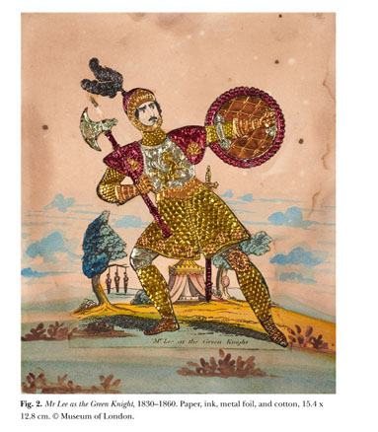
NOTES
(1.) See Locher 48-49.
(2.) Others have made the connection to the Earthly Paradise or Morris and Burne-Jones's collaborative manuscript projects without examining specific medial allusions as I do here. See, for instance, Prettejohn, who describes the Perseus series as a resumption of The Earthly Paradise scheme and its planned "union of word and image" (183).
(3.) The Death of Medusa I in Southampton includes the names of the represented characters.
(4.) Compared to Morris's poem, the text is highly condensed. For a translation, see Prettejohn 184.
(5.) The DemidoffAltarpiece: www.nationalgallery.org.uk/paintings/carlo-crivelli-the -virgin-and-child
(6.) Tate GalleryN03456:www.tate.org.uk/art/artworks/burne-jones-the-call-of-perseus -perseus-and-the-graiae-perseus-and-the-nereids-n03456
(7.) For an illustration, see Peterson 54.
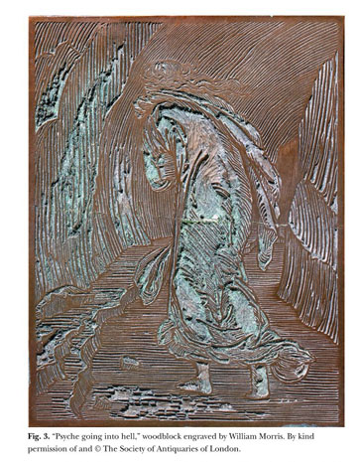
(8.) I follow Arscott's and/or Prettejohn's dating for most of the various versions.
(9.) Bodleian Library Arch. G b.6 (formerly Douce 310), fols. 001r, 005r.
(10.) See, for example, a Perseus card from c. 1825: www.loc.gov/resource/cph .3g10055/
(11.) Horner 29-30.
(12.) The clouds may allude to Ruskin's discussion of the Graiae as "soft rain-clouds" (142).
(13.) See Morris 254.
(14.) Burne-Jones also allowed Frederick Hollyer to make platinotypes of numerous paintings and drawings, and Agnew's and Colnaghi's to print photogravures of Briar Rose and King Cophetua and the Beggar Maid, respectively. See Newall 8-9.
(15.) The Stuttgart oil was translated into print; an etching by Felix Jasinski appeared in the Dec. 1893 issue of the Gazette des Beaux-Arts.
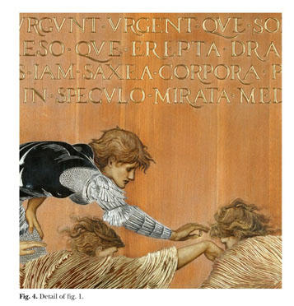
WORKS CITED
Armstrong, Carol. "Seurat's Media, or A Matrix of Materialities." Grey Room, vol. 58, 2015, pp. 6-25.
Arscott, Caroline. William Morris and Edward Burne-Jones: Interlacings. Paul Mellon Centre for Studies in British Art, Yale UP, 2008.
Burne-Jones, Edward. The Call of Perseus; Perseus and the Graiae; Perseus and the Nereids. 1875-76. Tate Britain, London. www.tate.org.uk/art/artworks/burne-jones-the-call -of-perseus-perseus-and-the-graiae-perseus-and-the-nereids-n03456. Accessed 24 Apr. 2020.
Crivelli, Carlo. The Virgin and Child from the Demidoff Atarpiece. 1476. National Gallery, London.www.nationalgallery.org.uk/paintings/carlo-criveUi-the-virgin-and-child.Accessed 24 Apr. 2020.
"The Grosvenor Gallery." The British Architect and Northern Engineer, vol. 9, no. 21, 24 May 1878, p. 239.
"The Grosvenor Gallery. Concluding Notice." The Magazine of Art, Jan. 1878, pp. 110-111.
Henchman, Anna. The Starry Sky Within: Astronomy and the Reach of the Mind in Victorian Literature. Oxford UP, 2014.
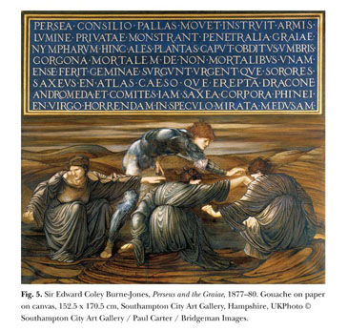
Horner, Frances. Time Remembered. Heinemann, 1933.
Jacobs, Joseph. "Some Recollections of Sir Edward Burne-Jones." The Nineteenth Century, vol. 45, no. 263, Jan. 1899, pp. 126-31.
Leprieur, Paul. "La Legende de Persee par M. Burne-Jones." Gazette des Beaux-Arts, vol. 10, 1 Dec. 1893, pp. 462-77.
Locher, Kurt. Der Perseus-Zyklus von Edward Burne-Jones. Staatsgalerie Stuttgart, 1973.
Morris, William. The Earthly Paradise. 3rd ed., vol. 1, F. S. Ellis, 1868.
Newall, Christopher. "Burne-Jones and his Printmakers." The Reproductive Engravings after Sir Edward Coley Burne-Jones. Julian Hartnoll, 1988, pp. 8-13.
"Our Guide to the Grosvenor Gallery." Punch, 22 Jun. 1878, p. 285.
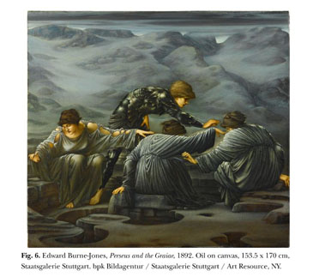
Perseus and Caput Medusae. Etched by Sidney Hall. 1825, https://www.loc.gov/resource /cph.3g10055/. Accessed 24 Apr. 2020.
Peterson, William S. The Kelmscott Press: A History of William Morris's Typographical Adventure. U of California P, 1991.
"The Picture Galleries IV." The Saturday Review, 1 Jun. 1878, pp. 691-92.
Prettejohn, Elizabeth. "The Series Paintings." Edward Burne-Jones, edited by Alison Smith, Tate Publishing, 2018, pp. 169-95, 224.
Ruskin, John. Modern Painters. Vol. 5, Smith, Elder and Co., 1860.
Smith, Alison. "At Work: Burne-Jones's Studio, Materials and Techniques." Edward Burne-Jones, edited by Alison Smith, Tate Publishing, 2018, pp. 23-33, 222.
Alison Syme (alison.syme@utoronto.ca) is an Associate Professor of Modern Art at the University of Toronto. She is the author of A Touch of Blossom: John Singer Sargent and the Flora of Fin-de-Siecle Art (Penn State UP, 2010), and she is currently writing a book on Edward Burne-Jones.
doi: 10.2979/victorianstudies.62.2.13
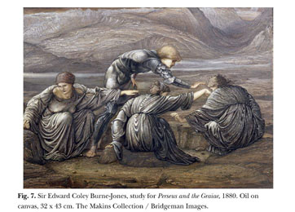
Caption: Fig. 1. Sir Edward Coley Burne-Jones, Perseus and the Graiae, 1877-78. Oil, gold, bronze, and silver leaf on gesso on oak panel, overpainted in gold, 170.2 * 153.2 cm, National Museum Wales, Cardiff. HIP / Art Resource, NY.
Caption: Fig. 2. Mr Lee as the Green Knight, 1830-1860. Paper, ink, metal foil, and cotton, 15.4 * 12.8 cm. [c] Museum of London.
Caption: Fig. 3. "Psyche going into hell," woodblock engraved by William Morris. By kind permission of and [c] The Society of Antiquaries of London.
Caption: Fig. 4. Detail of fig. 1.
Caption: Fig. 5. Sir Edward Coley Burne-Jones, Perseus and the Graiae, 1877-80. Gouache on paper on canvas, 152.5 * 170.5 cm, Southampton City Art Gallery, Hampshire, UKPhoto [c] Southampton City Art Gallery / Paul Carter / Bridgeman Images.
Caption: Fig. 6. Edward Burne-Jones, Perseus and the Graiae, 1892. Oil on canvas, 153.5 * 170 cm, Staatsgalerie Stuttgart. bpk Bildagentur / Staatsgalerie Stuttgart / Art Resource, NY
Caption: Fig. 7. Sir Edward Coley Burne-Jones, study for Perseus and the Graiae, 1880. Oil on canvas, 32 * 43 cm. The Makins Collection / Bridgeman Images.
Caption: Fig. 8. Charles W. Campbell, engraving after Edward Burne-Jones's Pan and Psyche, 1887. Mezzotint on paper, 35.6 * 29.9 cm. Courtesy of The Maas Gallery.
