Alternative realities

Edward Burne-Jones, caught between past and present
By Susan Owens
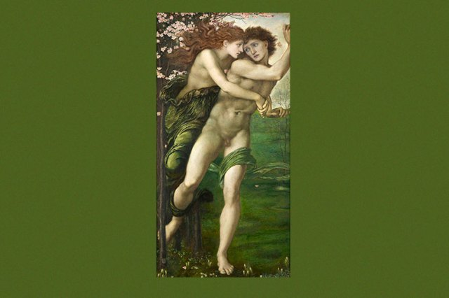
January 18, 2019

IN THIS REVIEW
EDWARD BURNE-JONES
Tate Britain, until February 24
It is odd that pictures by Edward Burne-Jones that we now think of as quintessentially Victorian were created as a reaction against his age. Burne-Jones longed to be anything but Victorian – which to him, brought up in industrial Birmingham, meant brashness, ugliness and preoccupation with novelty. His love of the Middle Ages, Arthurian literature, myth and legend, offered an alternative reality: an artistic space to inhabit that was both well away from the nasty nowadays and, of course, absolutely conditioned by them.
The monochrome pen-and-ink drawings hung at the beginning of Edward Burne-Jones are a case in point. Created in the late 1850s, they were described by Dante Gabriel Rossetti as “marvels of finish and imaginative detail, unequalled by anything unless perhaps Albert Dürer’s finest works”. Burne-Jones drew the courtly-love scene “Going to the Battle” (1858) on vellum, a material associated with medieval manuscripts, but its exceptionally fine lines and minute dots and dashes, made in emulation of Dürer’s engraved lines, betray his use of that nineteenth-century innovation, a steel-nibbed pen. Similarly, Burne-Jones’s many stained-glass designs may have been based on medieval prototypes, but their existence reflects the massive scale of Victorian church-building. This tension between past and present runs through this fine exhibition curated by Alison Smith and Tim Batchelor, the first major monographic show of the artist’s work since 1998.
It was a meeting in 1856 with Rossetti, the charismatic co-founder of the Pre-Raphaelite Brotherhood, that prompted Burne-Jones to drop out of Oxford, where he had been preparing to enter the church, and to take up art instead. He had relatively little formal training: Rossetti gave him some patchy instruction, and he attended life classes at a private art school. But essentially he was obliged to make it up as he went along. As Smith has pointed out, when you look at the series of watercolours hung chronologically in this first room, beginning on the left with compositions of the early 1860s such as “Cupid’s Forge” and “Clerk Saunders” and ending on the right with the landmark “Phyllis and Demophoön” (1870), you can see him getting better and better. His compositions become more assured, his colours subtler, his handling more …

